Ex:1

1) Create a table name STUDENT with following structure.

|  |  |  |  |  |
| --- | --- | --- | --- | --- |
|  | **Column** |  |  |  |
| **S.nO** | **Name** | **Description** | **Data Type** |  |
|  |  |  |
|  |  | Registration |  |  |
| 1 | RegNo | Number | NUMBER(3) |  |
| 2 | Name | Student Name | VARCHAR(15) |  |
|  |  | Gender of the |  |  |
| 3 | Gender | student | CHAR(1) |  |
| 4 | DOB | Date of Birth | DATE |  |
| 5 | MobileNo | Mobile Number | NUMBER(10) |  |
| 6 | City | Location of stay | VARCHAR(15) |  |

Ans:-

mysql> create database d4;

Query OK, 1 row affected (0.00 sec)

mysql> use d4;

Database changed

mysql> create table student(regno integer(3),name varchar(15),gender char(1),dob date,mobileno varchar(10),city varchar(15));

Query OK, 0 rows affected (0.01 sec)

mysql> desc student;

+----------+-------------+------+-----+---------+-------+

| Field | Type | Null | Key | Default | Extra |

+----------+-------------+------+-----+---------+-------+

| regno | int(3) | YES | | NULL | |

| name | varchar(15) | YES | | NULL | |

| gender | char(1) | YES | | NULL | |

| dob | date | YES | | NULL | |

| mobileno | varchar(10) | YES | | NULL | |

| city | varchar(15) | YES | | NULL | |

+----------+-------------+------+-----+---------+-------+

6 rows in set (0.01 sec)

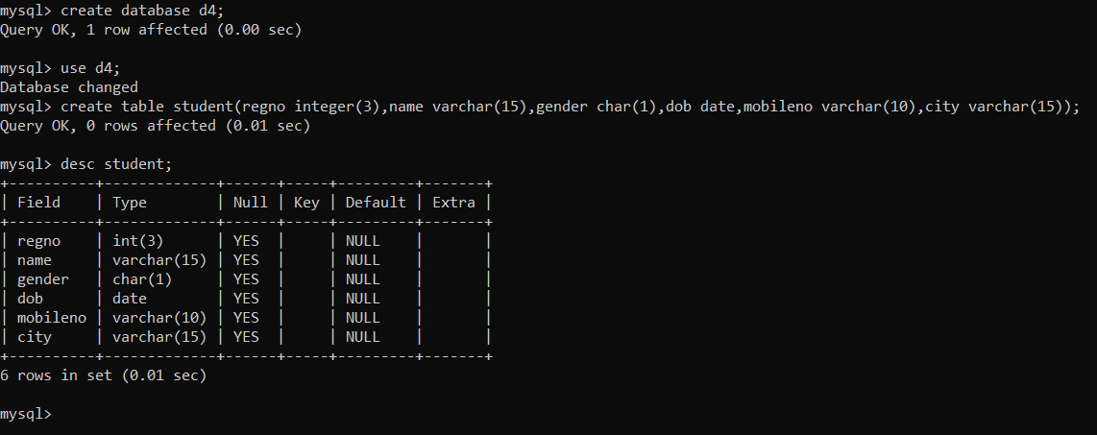

2) Create a table name FACULTY with following structure.

|  |  |  |  |  |
| --- | --- | --- | --- | --- |
|  | **Column** |  |  |  |
| **S.nO** | **Name** | **Description** | **Data Type** |  |
|  |  |  |
| 1 | FacNo | Faculty Identifier | VARCHAR(4) |  |
| 2 | FacName | Faculty Name | VARCHAR(15) |  |
| 3 | Gender | Gender of faculty | CHAR(1) |  |
| 4 | DOB | Date of Birth | DATE |  |
| 5 | DOJ | Date of Join | DATE |  |
| 6 | MobileNo | Mobile Number | NUMBER(10) |  |
|  |  |  |  |  |

Ans:-

mysql> create table faculty(facno varchar(4),facname varchar(15),gender char(1),dob date,doj date,mobileno varchar(10));

Query OK, 0 rows affected (0.01 sec)

mysql> desc faculty;

+----------+-------------+------+-----+---------+-------+

| Field | Type | Null | Key | Default | Extra |

+----------+-------------+------+-----+---------+-------+

| facno | varchar(4) | YES | | NULL | |

| facname | varchar(15) | YES | | NULL | |

| gender | char(1) | YES | | NULL | |

| dob | date | YES | | NULL | |

| doj | date | YES | | NULL | |

| mobileno | varchar(10) | YES | | NULL | |

+----------+-------------+------+-----+---------+-------+

6 rows in set (0.01 sec)

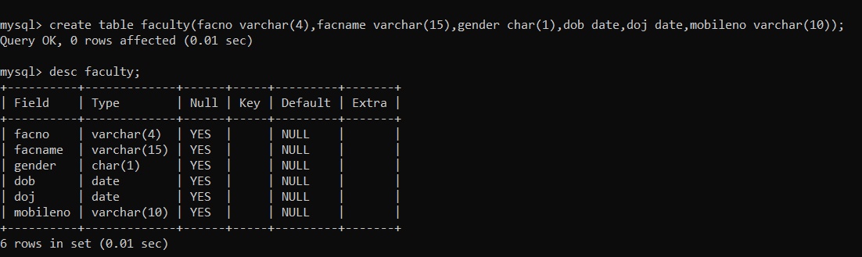

3) Create a table name DEPARTMENT with following structure.

|  |  |  |  |  |
| --- | --- | --- | --- | --- |
|  | **Column** |  |  |  |
| **S.nO** | **Name** | **Description** | **Data Type** |  |
|  |  |  |
| 1 | DeptNo | Department Identifier | VARCHAR(4) |  |
| 2 | DeptName | Department Name | VARCHAR(15) |  |
| 3 | DeptHead | Department Head | VARCHAR(4) |  |

Ans:-

mysql> create table department(deptno varchar(4),deptname varchar(15),depthead varchar(4));

Query OK, 0 rows affected (0.01 sec)

mysql> desc department;

+----------+-------------+------+-----+---------+-------+

| Field | Type | Null | Key | Default | Extra |

+----------+-------------+------+-----+---------+-------+

| deptno | varchar(4) | YES | | NULL | |

| deptname | varchar(15) | YES | | NULL | |

| depthead | varchar(4) | YES | | NULL | |

+----------+-------------+------+-----+---------+-------+

3 rows in set (0.01 sec)

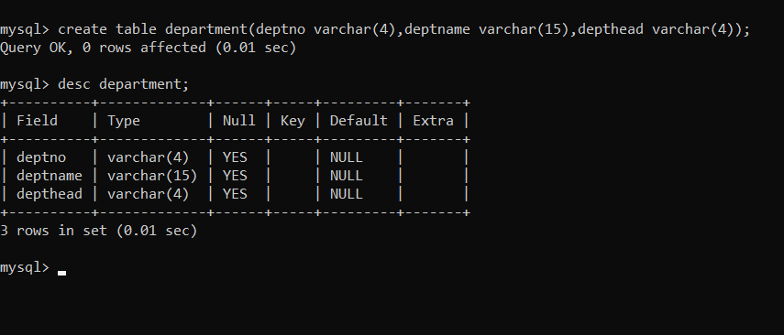

4) Create a table name COURSE with following structure.

|  |  |  |  |  |
| --- | --- | --- | --- | --- |
|  | **Column** |  |  |  |
| **S.nO** | **Name** | **Description** | **Data Type** |  |
|  |  |  |
| 1 | CourseNo | Course Identifier | VARCHAR(3) |  |
|  |  | Course |  |  |
| 2 | CourseDesc | Description | VARCHAR(14) |  |
| 3 | CourseType | Course Type | CHAR(1) |  |
| 4 | SemNo | Semester Number | CHAR(1) |  |
| 5 | HallNo | Hall Number | VARCHAR(4) |  |
| 6 | FacNo | Faculty Identifier | VARCHAR(4) |  |

Ans:-

mysql> create table course(courseno varchar(3),coursedesc varchar(14),coursetype char(1),semno char(1),hallno varchar(4),facno varchar(4));

Query OK, 0 rows affected (0.01 sec)

mysql> desc course;

+------------+-------------+------+-----+---------+-------+

| Field | Type | Null | Key | Default | Extra |

+------------+-------------+------+-----+---------+-------+

| courseno | varchar(3) | YES | | NULL | |

| coursedesc | varchar(14) | YES | | NULL | |

| coursetype | char(1) | YES | | NULL | |

| semno | char(1) | YES | | NULL | |

| hallno | varchar(4) | YES | | NULL | |

| facno | varchar(4) | YES | | NULL | |

+------------+-------------+------+-----+---------+-------+

6 rows in set (0.01 sec)

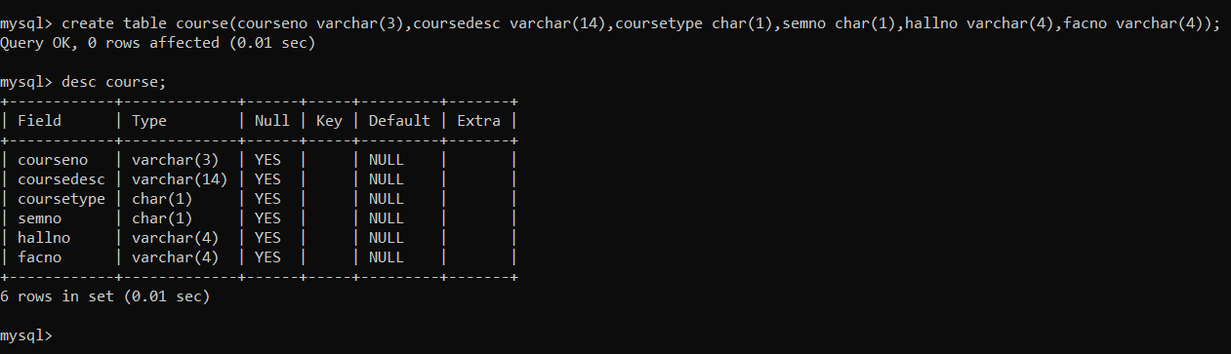

5) Modify the table FACULTY by adding a column name DeptNo of datatype VARCHAR(4)

Ans:-

mysql> alter table faculty add deptno varchar(4);

Query OK, 0 rows affected (0.06 sec)

Records: 0 Duplicates: 0 Warnings: 0

mysql> desc faculty;

+----------+-------------+------+-----+---------+-------+

| Field | Type | Null | Key | Default | Extra |

+----------+-------------+------+-----+---------+-------+

| facno | varchar(4) | YES | | NULL | |

| facname | varchar(15) | YES | | NULL | |

| gender | char(1) | YES | | NULL | |

| dob | date | YES | | NULL | |

| doj | date | YES | | NULL | |

| mobileno | varchar(10) | YES | | NULL | |

| deptno | varchar(4) | YES | | NULL | |

+----------+-------------+------+-----+---------+-------+

7 rows in set (0.01 sec)

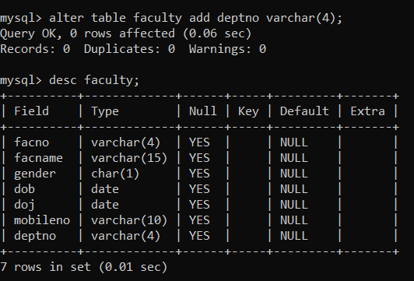

Ex-2

1. Alter the table STUDENT with following structure.

|  |  |  |
| --- | --- | --- |
| S.No | Column | Constraints |
| 1 | RegNo | PRIMARY KEY |
| 2 | MobileNo | NotNull |

Ans:-

mysql> alter table student add primary key(regno);

Query OK, 0 rows affected (0.03 sec)

Records: 0 Duplicates: 0 Warnings: 0

mysql> alter table student modify mobileno varchar(10) not null;

Query OK, 0 rows affected (0.03 sec)

Records: 0 Duplicates: 0 Warnings: 0

mysql> desc student;

+----------+-------------+------+-----+---------+-------+

| Field | Type | Null | Key | Default | Extra |

+----------+-------------+------+-----+---------+-------+

| regno | int(3) | NO | PRI | 0 | |

| name | varchar(15) | YES | | NULL | |

| gender | char(1) | YES | | NULL | |

| dob | date | YES | | NULL | |

| mobileno | varchar(10) | NO | | NULL | |

| city | varchar(15) | YES | | NULL | |

+----------+-------------+------+-----+---------+-------+

6 rows in set (0.01 sec)

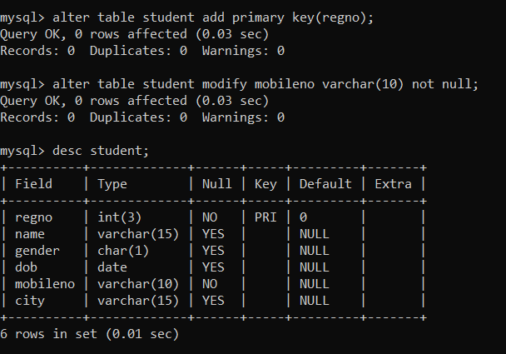

1. Alter the table name FACULTY with following structure. The DeptNo in this table refers the DeptNo in the DEPARTMENT table.

|  |  |  |
| --- | --- | --- |
| S.No | Column | Constraints |
| 1 | FacNo | PRIMARY KEY |
| 2 | Gender | Check ‘M’ or ‘F’ |

Ans:-

mysql> alter table faculty add primary key(facno);

Query OK, 0 rows affected (0.03 sec)

Records: 0 Duplicates: 0 Warnings: 0

mysql> alter table faculty add check(gender='M' or 'F');

Query OK, 0 rows affected (0.01 sec)

Records: 0 Duplicates: 0 Warnings: 0

mysql> desc faculty;

+----------+-------------+------+-----+---------+-------+

| Field | Type | Null | Key | Default | Extra |

+----------+-------------+------+-----+---------+-------+

| facno | varchar(4) | NO | PRI | | |

| facname | varchar(15) | YES | | NULL | |

| gender | char(1) | YES | | NULL | |

| dob | date | YES | | NULL | |

| doj | date | YES | | NULL | |

| mobileno | varchar(10) | YES | | NULL | |

+----------+-------------+------+-----+---------+-------+

6 rows in set (0.02 sec)

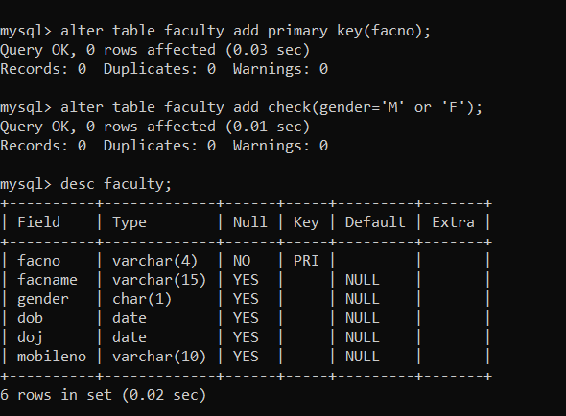

4)Alter the table name DEPARTMENT with following structure.

|  |  |  |
| --- | --- | --- |
| S.No | Column | Constraints |
| 1 | DeptNo | PRIMARY KEY |

Ans:-

mysql> alter table department add primary key(deptno);

Query OK, 0 rows affected (0.03 sec)

Records: 0 Duplicates: 0 Warnings: 0

mysql> desc department;

+----------+-------------+------+-----+---------+-------+

| Field | Type | Null | Key | Default | Extra |

+----------+-------------+------+-----+---------+-------+

| deptno | varchar(4) | NO | PRI | | |

| deptname | varchar(15) | YES | | NULL | |

| depthead | varchar(4) | YES | | NULL | |

+----------+-------------+------+-----+---------+-------+

3 rows in set (0.00 sec)

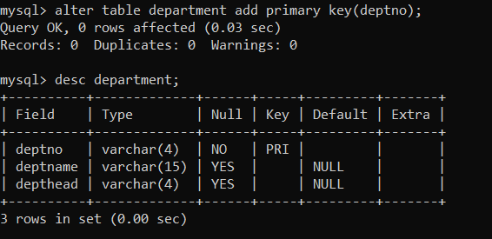

5). Alter the table name COURSE with following Structure

|  |  |  |
| --- | --- | --- |
| S.No | Column | Constraints |
| 1 | CourseNo | PRIMARY KEY |
| 2 | SemNo | 1 to 6 |
|  |  |  |

Ans:-

mysql> alter table course add primary key(courseno);

Query OK, 0 rows affected (0.05 sec)

Records: 0 Duplicates: 0 Warnings: 0

mysql> alter table course add check (semno between 1 and 6);

Query OK, 0 rows affected (0.03 sec)

Records: 0 Duplicates: 0 Warnings: 0

mysql> desc course;

+------------+-------------+------+-----+---------+-------+

| Field | Type | Null | Key | Default | Extra |

+------------+-------------+------+-----+---------+-------+

| courseno | varchar(3) | NO | PRI | | |

| coursedesc | varchar(14) | YES | | NULL | |

| coursetype | char(1) | YES | | NULL | |

| semno | char(1) | YES | | NULL | |

| hallno | varchar(4) | YES | | NULL | |

| facno | varchar(4) | YES | | NULL | |

+------------+-------------+------+-----+---------+-------+

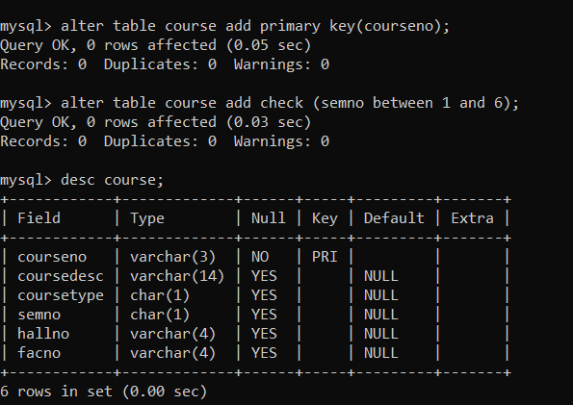

***Exp:-3***

1. Populate all the five tables with your own data

Ans:-

mysql> insert into student values(123,'rajkumar','m','2022-09-08',1234567891,'chennai');

Query OK, 1 row affected (0.00 sec)

mysql> select * from student;

+-------+----------+--------+------------+------------+---------+

| regno | name | gender | dob | mobileno | city |

+-------+----------+--------+------------+------------+---------+

| 123 | rajkumar | m | 2022-09-08 | 1234567891 | chennai |

+-------+----------+--------+------------+------------+---------+

1. row in set (0.00 sec)

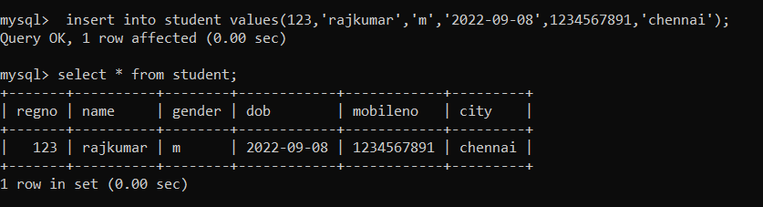

2). Update the value of student name whose register number is ‘191711342’

Ans:-

mysql> update student set name='bino' where regno=123;

Query OK, 1 row affected (0.02 sec)

Rows matched: 1 Changed: 1 Warnings: 0

mysql> select * from student;

+-------+------+--------+------------+------------+---------+

| regno | name | gender | dob | mobileno | city |

+-------+------+--------+------------+------------+---------+

| 123 | bino | m | 2022-09-08 | 1234567891 | chennai |

+-------+------+--------+------------+------------+---------+

1 row in set (0.00 sec)

